


National Action Plan on Business and Human Rights

Report on the Trade Union Consultation Event

Wednesday 8th November
9.30 – 12:30
Unite Scotland
22 York Place, Edinburgh
EH1 3EP


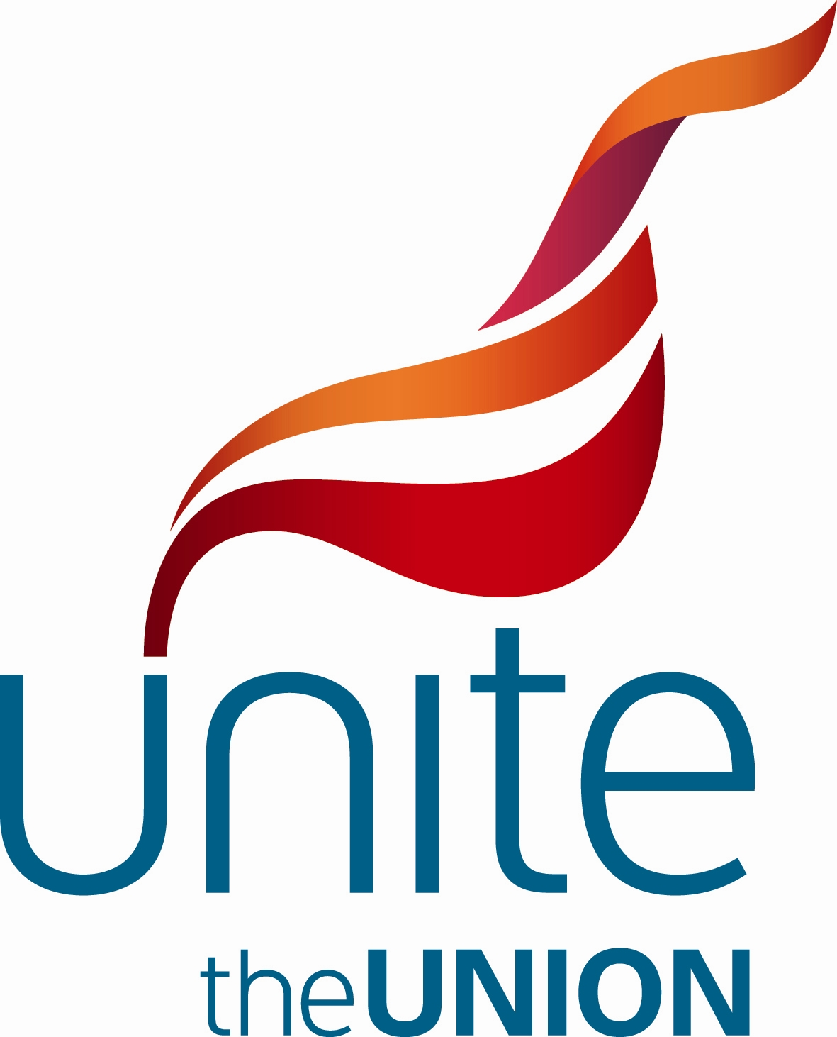

Business and Human Rights National Action Plan

Background and Purpose
A national consultation and planning process is underway to develop a National Action Plan (NAP) to implement the UN Guiding Principles on Business and Human Rights (UNGPs) in Scotland. The process is being led by the Scottish Government, the Scottish Human Rights Commission, Scottish Enterprise and civil society, and is informed by a National Baseline Assessment (NBA), commissioned by the Scottish Government and published in October 2016.
As key stakeholders, it is important that trade unions in Scotland are given the opportunity to comment and contribute to the NAP development.
A consultation event, chaired by Helen Martin (Assistant General Secretary, STUC), took place on Wednesday 8th November. Three introductory presentations helped to inform participants and provide a basis for discussion.
Martin Reid (Head of Fair Workplaces Unit, Scottish Government) described the legal and policy framework in Scotland, , with particular regard for the fair work agenda, payment of the Living Wage, and the devolution of employment tribunals to Scotland. The Scottish Government reiterated its commitment to the NAP process.
Diego Quiroz (Policy Officer, Scottish Human Rights Commission) presented an overview of the NAP process, the UNGPs and the key findings emerging from the NBA.
Carole Ewart (Consultant) highlighted key learning, both domestically and internationally, including implementation of Scotland’s National Action Plan for Human Rights (SNAP) and the UK Joint Committee on Human Rights 2017 human rights and business report.
The discussion that followed was framed around two questions:
- What are the main issues in terms of workers’ rights / human rights that should be considered for SNAP?

- Do the NBA recommendations accurately reflect the experiences of trade unions in relation to human rights in Scotland? What gaps can you see in the NBA?

Trade union priorities and suggestions for matters to include in a Scottish NAP to make it as effective as possible within the Scottish legal and regulatory framework included:

General points:

- The NAP should be a catalyst and create a forum for challenging poor and unlawful corporate practice.

- The NAP should have a strong foundation on workers’ rights such as the eight fundamental ILO Conventions.

- Understanding human rights is key to the process: efforts must be made to help citizens, employees, businesses and organisations across all sectors understand human rights better by, for example, launching a campaign that facilitates the implementation of the NAP.

- Concerns about the implementation of the NAP arose repeatedly in the discussion and there were suggestions that the Scottish Government and a specific government department take a ‘co-ordinating’ role to ensure change happens.

- The NAP should develop ambitious targets and must set clear priorities and timelines.

- The NAP should include enforcement measures to drive out poor practice, for example more needs to be done in relation to the minimum wage.

- The NAP should promote direct cooperation between management and workers in decision-making, so that potential employment problems can be prevented at source by trade unions

- The NAP should prioritise actions within industry sectors where there are already significant human rights concerns e.g. health and social care provision, and the construction sector.

- The NAP needs to recognise and address current weak procurement practice through changes in the law and innovative approaches if a legislative change is not possible.

- Scottish Government guidance on the application of human rights considerations to public sector procurement must be made available.

- Trade Unions should be vehicles to deliver the NAP.

Specific issues:

- There is a need to clarify the definition of employment status, which affects employment rights and employer responsibilities in the workplace

- The NAP should focus on the groups at risk of vulnerability and marginalisation such as, but not limited to, ethnic minorities and foreign nationals.

- The NAP should focus on greater access to remedies for victims of human rights harms involving business enterprises.

- Subcontracting creates opportunities for tax avoidance and poor working conditions. Zero hours contracts are considered to be one major example of how Scotland/UK’s working population is being exploited and workers’ rights undermined.

- Public procurement occupied a large portion of the conversation. There were a number of ideas around the subject, including:
- companies which already comply with the UNGPs should be proactively invited to bid for public sector contracts and procurement opportunities
- companies which breach human rights should be excluded for a minimum period
- Scottish Government guidance on the application of human rights considerations to public sector procurement must be made more explicit and binding;
- Audit Scotland can play a role on oversight of procurement process to ensure a fair, equal and open process that leads to better socio- economic outcomes, and to monitor compliance.

- The National Minimum Wage and National Living Wage were discussed as well as the process to calculate it by employers.

- Greater oversight and progressive regulation need to be explored.

Summary and next steps (SHRC)
The views expressed in this event will inform the drafting of the NAP and a further public consultation on the draft will be carried out in Autumn 2018. The Better World Action Group will contact trade unions to invite one of their members to be part of the NAP drafting group.

This report is intended for circulation to the participants of the event who are invited to endorse the contents and comment directly to diego.quiroz@scottishhumanrights by the 30 November 2017.

End.

