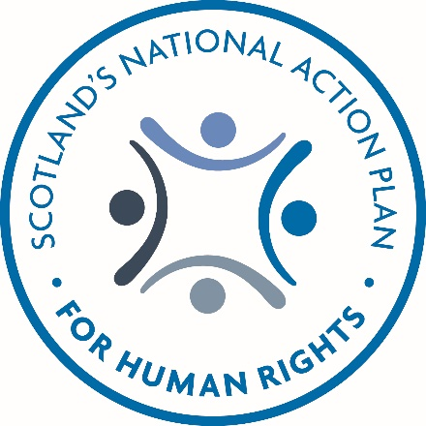
SNAP 2

We want to know what you think about Scotland’s second National Action Plan for Human Rights

Copyright images © Photosymbols. Prepared by Disability Equality Scotland
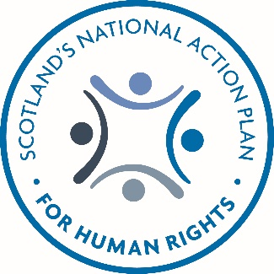  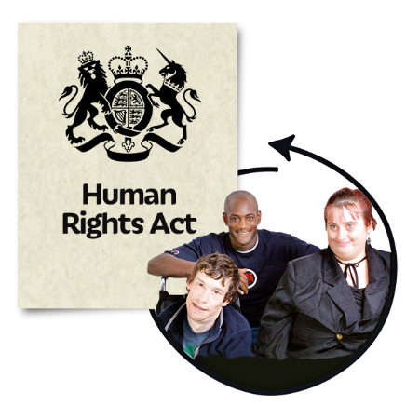 | 1. Introduction  This document is about Scotland’s second National Action Plan for Human Rights (SNAP 2).  It tells how SNAP worked and how SNAP 2 started.  We want to know what you think about SNAP2.

2. What was SNAP 2013-2017?

SNAP was the first National Action Plan for Human Rights in any part of the UK.

SNAP was run by the Scottish Human Rights Commission and lots of people and organisations worked on it together.

We want everyone in Scotland to have human rights and to be able to stand up for them.

SNAP started in 2013 on International Human Rights Day and finished in December 2017.
SNAP’s work had three themes.

Better Human Rights Culture – human rights is part of our lives.

Better Lives – we have happy, safe and healthy lives.

Better World – how Scotland works with other countries.
How did we know SNAP worked well?

In 2017 we asked lots of people what they thought of SNAP at events and through an online survey.

You can read a report from the National Participation Process online at: www.snaprights.info

There was a report each year about the work SNAP was doing and how well it was working.

The reports went to the Scottish Parliament and to people and organisations who are interested in human rights in Scotland.

You can read these reports online at: www.snaprights.info
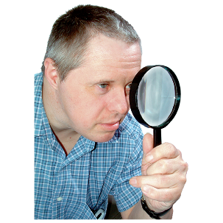 | In 2018 Doctor Jo Ferrie of the University of Glasgow looked at SNAP to see if it was working well.  You can read the Evaluation Report online at: www.snaprights.info
Since July 2018, a group has worked on SNAP 2.
There is a list of their names at the end of this document.

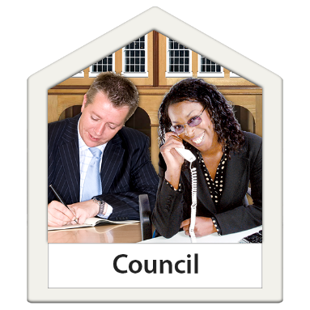  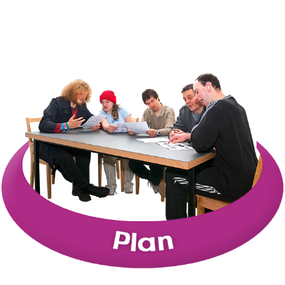 | 3. SNAP 2: 2030 Outcomes  There are seven things that SNAP 2 wants to do by 2030.  Empowerment: We all understand what human rights are and feel confident to put them into action in all parts of our lives.  Participation: We can all be part of making decisions that affect our human rights, and the rights of others.  Delivery of Public Services: Organisations that provide public services value human rights and put them at the centre of their work.  Access to Public Services: We all get good public services that work well and treat us with respect.
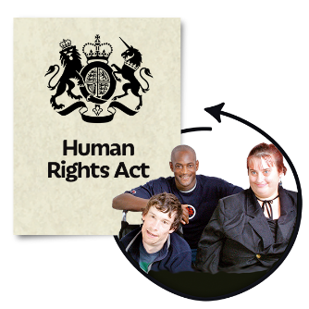 | International Obligations: Scotland learns from other countries and promotes human rights in all the work it does in other countries.  Accountability: All organisations make sure they follow human rights laws.  Equality: Scotland is a country where people are equal and have the same chances in life.
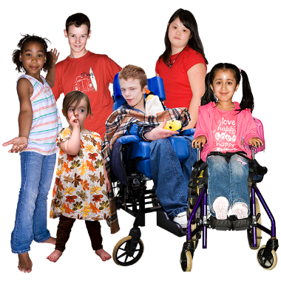 | 4. SNAP 2: 25 Themes  There are 25 human rights themes in SNAP 2.  - Children and Young People’s Rights  - Cultural Rights – Rights of Gypsy/Travellers  - D/deaf and Disabled People’s Rights  - Equality and Freedom from Discrimination
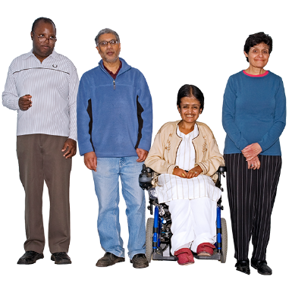  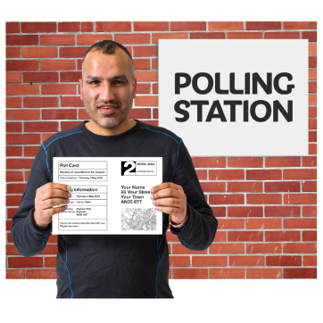  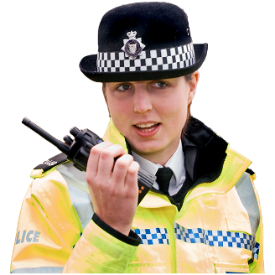 | - Freedom of Expression  - Freedom of Faith and Belief  - Freedom from Violence, Abuse and Neglect  - Justice – Access to Justice, Policing and Criminal Justice  - Mental Health  - Older People’s Rights  - Personal Choice and Autonomy  - Right to Adequate Standard of Living  - Right to Education  - Right to Employment / Workers’ Rights  - Right to Housing  - Right to Participation  - Right to Participation in Democratic Process / Voting  - Right to Physical Health  - Right to Private and Family Life  - Right to Social Security  - Rights of LGBTQI People  - Rights of People from Black and Minority Ethnic Groups  - Rights of Refugees and People Seeking Asylum  - Social Care and Right to Independent Living  - Women’s Rights
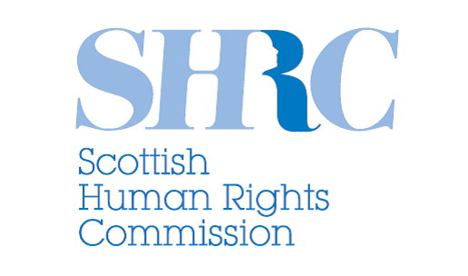  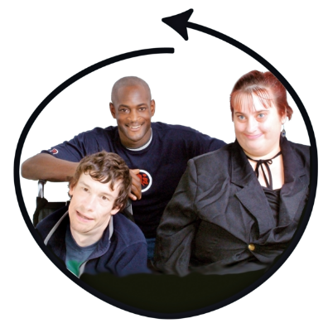 | 5. SNAP 2  How will it work?  Who makes sure it works well?  What things does it have to do the job?  A Secretariat is the group that give admin support to SNAP 2 including:  - Preparing materials for SNAP 2 meetings and events  - Letting people know about what SNAP 2 is doing. For example on a website, social media, and in reports  - Looking at how well SNAP 2 is working and making a report  - Getting people involved in the work of SNAP 2 including people who have experience of human rights issues in their lives  The Secretariat could be from the Scottish Human Rights Commission or another SNAP partner organisation.

Who makes sure SNAP 2 works well?

People involved with SNAP 2 are from:
- the Scottish Government
- the Scottish Human Rights Commission
- organisations that give us public services
- people with experience of human rights issues in their lives
- organisations who are not part of government

What resources does SNAP 2 have so it can do its work?

SNAP 2 would like money from the Scottish Government:
- for the costs of the Secretariat
- to do the work of SNAP 2
- to make reports

Who will SNAP 2 work with?

SNAP 2 will work with the National Taskforce for Human Rights Leadership that was started by the Scottish Government.
The Chairs of the Taskforce are Shirley Anne Somerville MSP and Professor Alan Miller of Strathclyde University.
People on the Taskforce are from:
- organisations who check standards are being followed
- organisations not part of government
- local government
- the Scottish Human Rights Commission
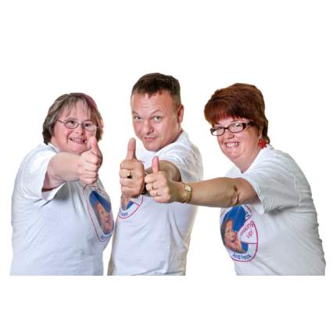  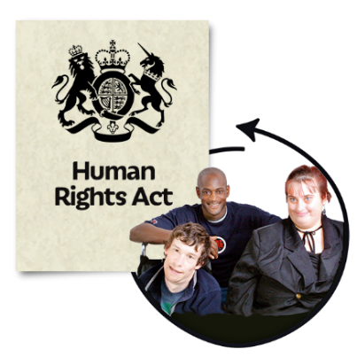 | The Taskforce will:  - Make an Act of the Scottish Parliament about human rights  - Make sure the public are involved with what the new Act is about  - Add human rights into Scotland’s National Performance Framework -  how we work to make Scotland a more successful country where everyone has opportunities.  - Make sure the Act becoming law will make people’s lives better.  - Make a new system so the Scottish Government can see how well human rights are working
SNAP 2 wants to work with the Scottish Parliament.
The Parliament should:
- talk about SNAP2
- have a meeting every year about the work SNAP 2 is doing
- plan how to work with SNAP

List of people on SNAP 2 Development Working Group

- Adequate Standard of Living Reference Group
- CoSLA (local councils)
- Engender
- Equality and Human Rights Commission
- Health and Social Care ALLIANCE
- Human Rights Consortium Scotland
- NHS Health Scotland
- Police Scotland
- Scottish Council for Voluntary Organisations
- Scottish Care
- Scottish Councils Equality Network
- Scottish Government
- Scottish Human Rights Commission
- Scottish Children’s Rights Alliance
- Unite

Copyright images © Photosymbols. Prepared by Disability Equality Scotland

